**Clean This Dataset**

**Install and Launch Power BI:** If you haven't already, you can download and install Power BI Desktop from the official Microsoft website. Once installed, launch the application.

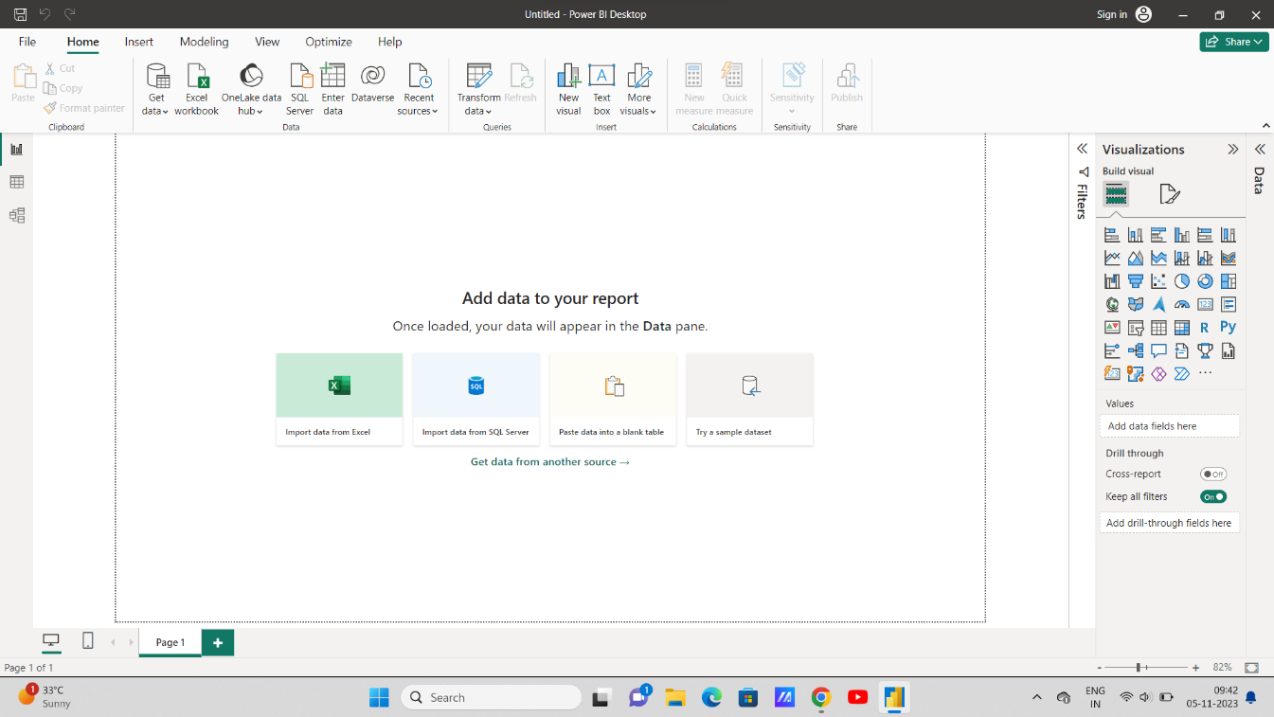

**Get Data:**

• When you open Power BI, you'll see the "Home" tab. Click on the "Get Data" button to start importing your data.

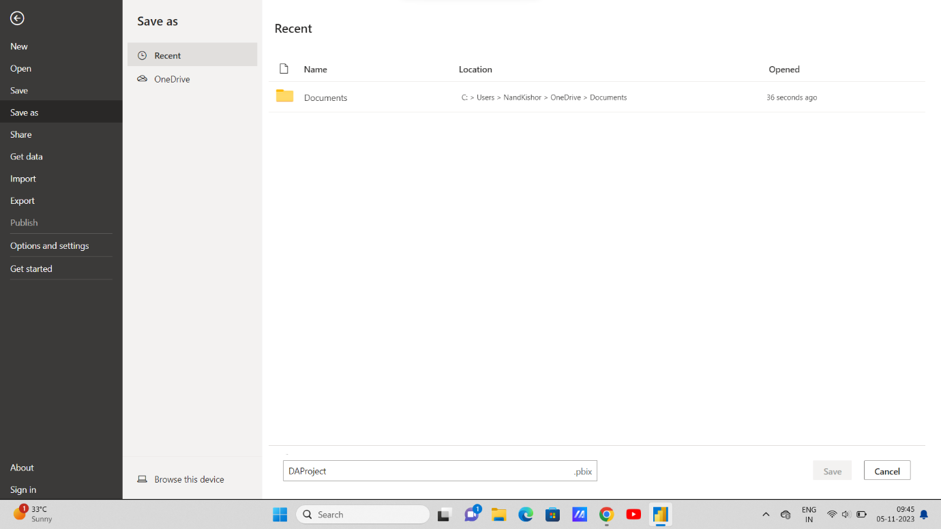

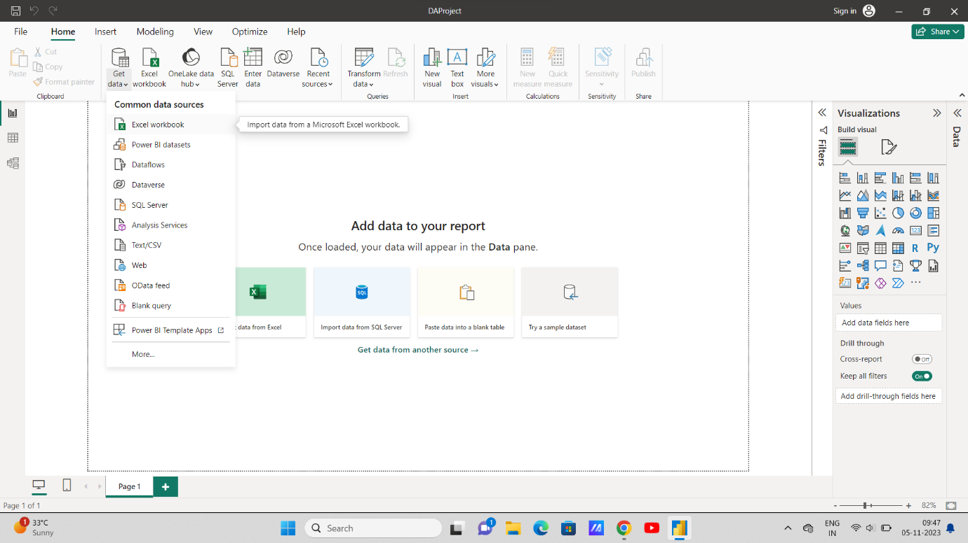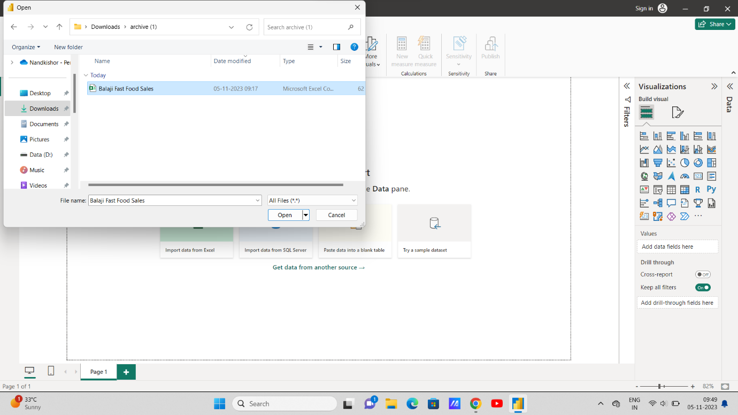

**Link This File:-**

**Choose a Data Source**:

• Power BI supports various data sources, such as Excel, databases, web services, and more. Select the appropriate source for your data. For example, if you have an Excel file, choose "CSV" and browse for your file.

**Data Load and Transformation:**

• Once you connect to your data, Power BI will load it into the Query Editor. Here, you can transform and clean your data. You can remove unnecessary columns, rename columns, filter rows, and perform other data cleaning operations.

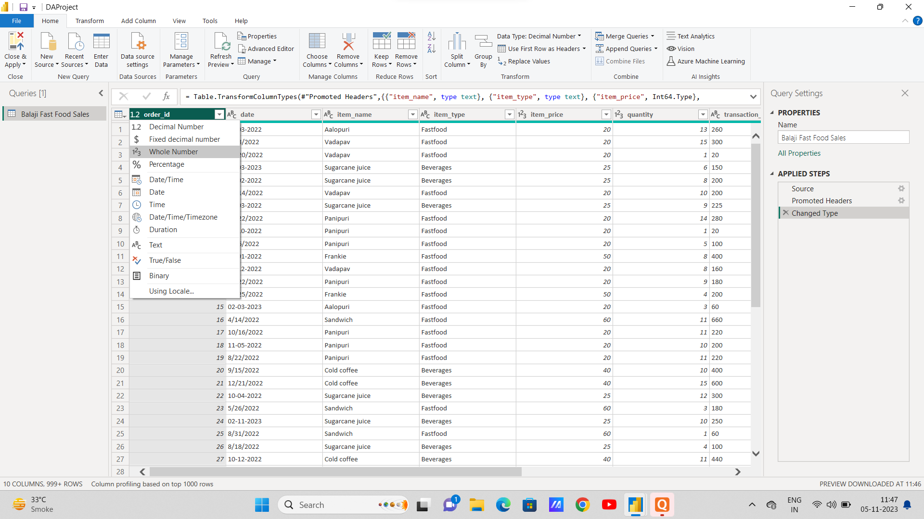

**Filter Rows:**

Click on the filter icon in a column header to filter rows based on specific conditions.

**Remove Rows:**

You can remove duplicate rows, empty rows, or rows that don't meet your criteria.

**Sort Data:**

Sort your data by one or more columns to make it easier to analyze.

**Rename Columns:**

Right-click on a column header and select "Rename" to give the column a more meaningful name.

**Change Data Types:**

You can change the data type of a column (e.g., from text to date) by selecting a column and using the "Data Type" option in the "Transform" tab.

**Split and Merge Columns:**

You can split one column into multiple columns or merge multiple columns into one using the "Split Column" or "Merge Columns" options.

**Replace Values:**

Replace values in a column with other values using the "Replace Values" function.

**Aggregate Data:**

Use functions like "Group By" to aggregate data based on specific columns.

Apply Custom Transformations:

You can write custom M or DAX expressions for more advanced data cleaning and transformation tasks.

**Preview Data:**

* + As you apply transformations, you can click the "Preview" button to see how your data will look after cleaning.

**Close and Apply:**

* + After you've cleaned and transformed your data, click the "Close & Apply" button to save the changes and load the cleaned data into Power BI.

**Visualize Data:**

* + With your clean data loaded, you can now create visualizations, including charts, graphs, and tables, to analyze and present your data effectively.

**Save Your Work:**

* + Save your Power BI project file (PBIX) to retain your data and transformations.

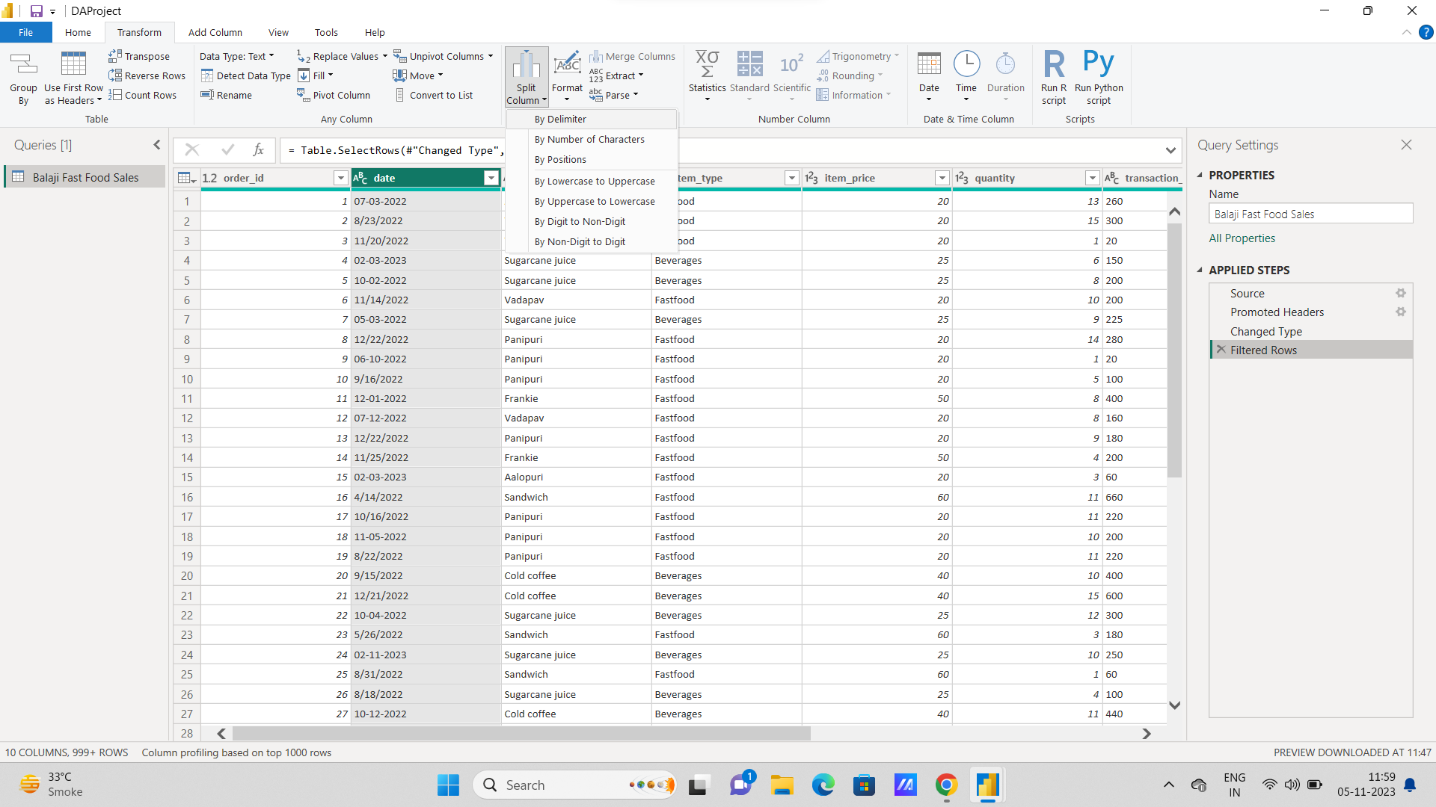

**Change Data type of Date:**

1. Change Data Type:

• Click on the header of the column that contains the text data.

• Go to the "Transform" tab in the Query Editor ribbon.

2. Choose the Data Type:

• Look for the "Data Type" dropdown in the "Transform" tab.

• Click the dropdown and select "Date" or "Date/Time" based on your requirements.

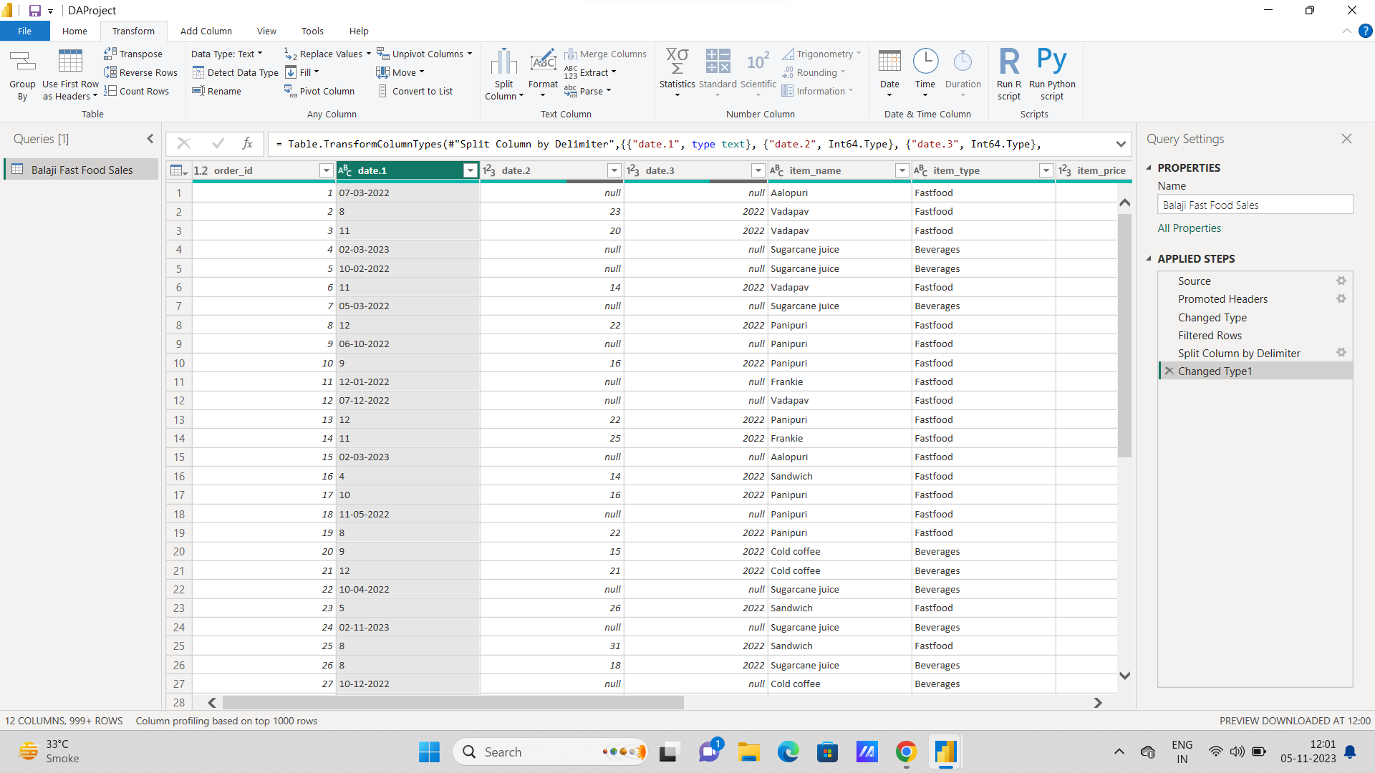

1. **Parse Using Locale (Optional):**

• If the text data is in a specific format that Power BI doesn't recognize as a date, you can use the "Parse" option.

• Click on the column, go to the "Transform" tab, and choose "Parse" where you can specify the date format using options like "Locale" or "Custom."

2. **Close & Apply:**

• After changing the data type, click on "Close & Apply" in the top-left corner of the Query Editor to apply the changes and load the updated data into Power BI.